what is jUnit
what is Maven
assertion and annotations
lifeCycle
Junit 5 architecture

unit test with a small pic of code that call your call and

you are write a cake
test check

-] In test you press one button and know everything should work
-] Junit is the lib that gives you the tool to check and test

Every test follow the same three steps:
1} Arrange -- set things up-Calculator calc = new Calculator();
2} Act -- do the thing-int result = calc.add(2, 3);
3} Assert: check the answer-assertEquals(5, result);

What is Maven in Java?
Maven is a build automation and project management tool for Java projects.

It helps you:
1. Download dependencies — automatically downloads libraries such as JUnit.
2. Compile code — converts your Java source code into bytecode.
3. Run tests — runs your tests using commands.
4. Package your project — creates a JAR or WAR file.
5. Manage library versions — helps you specify which version of a library your project needs.

-Simple real-life example 👨‍🍳
Imagine you are a chef:
- You (the chef): Write the recipe → Java code.
- Shopping list: pom.xml → specifies the libraries and versions you need.
- Kitchen manager: Maven → downloads the required ingredients (libraries) and manages the cooking process (build).
- Final dish: JAR file → your packaged Java application.

-What is pom.xml?
pom.xml stands for Project Object Model. It tells Maven what your project needs and how it should be built.

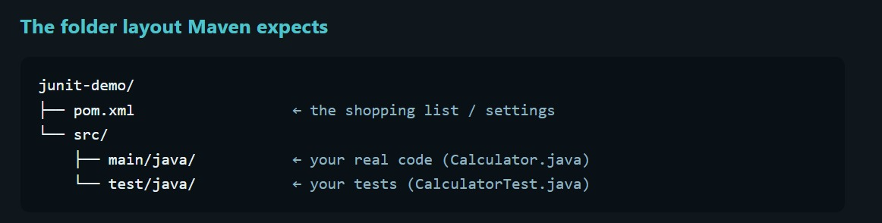
This tells Maven which JUnit library and version your project needs for testing.
Important Maven commands
Command | What it does
mvn compile | Compiles your Java code
mvn test | Compiles and runs tests
mvn package | Packages your application into a JAR or WAR
mvn clean | Removes generated build files
mvn install | Builds and saves the package in your local Maven repository

Steps to write JUnit test cases
1}
Understand the design
Understand what the method or program is supposed to do, its inputs, and its expected outputs.
- Example: add(5, 3) should return 8.
2}
Understand the pseudocode
Write the logic in simple English before writing Java code.
Example: Take two numbers → add them → return the result.
3}
Identify test cases
Think about normal inputs, boundary cases, and invalid inputs.
- add(5, 3) → 8
- add(0, 0) → 0
- add(-2, 3) → 1
4}
Write the JUnit test
Use @Test to identify a test method and assertEquals() to compare the expected result with the actual result.
5}
Execute and analyze
Run the test using IntelliJ IDEA or Maven. If the test fails, check the expected result, actual result, and program logic.

JUnit 5 – Introduction and Testing Architecture
1. What is JUnit?
JUnit is a unit-testing framework for Java. It helps developers test individual methods or small parts of a program to verify that they produce the expected results.
Example: If a method adds two numbers, JUnit can check whether add(5, 3) returns 8.
2. JUnit Testing Architecture
The main components of the JUnit 5 architecture are:
- JUnit Platform: Provides the foundation for launching testing frameworks and test engines.
- JUnit Jupiter: Provides the programming model and annotations used to write modern JUnit tests.
- Jupiter Test Engine: Discovers and executes tests written using the JUnit Jupiter programming model.
Working Flow
Java Application and Test Code → JUnit Platform → JUnit Jupiter Test Engine → Test Execution and Results
The results indicate whether the tests passed or failed.
3. What Is a Test Engine?
A test engine is a component responsible for discovering and executing tests written using a particular testing framework.
Important JUnit components:
- junit-jupiter-api: Provides annotations such as @Test, @BeforeEach, and @AfterEach.
- junit-jupiter-engine: Discovers and executes JUnit Jupiter tests.
- junit-vintage-engine: Allows older JUnit 3 and JUnit 4 tests to run on the JUnit Platform.
4. What Is Maven Surefire?
Maven Surefire is a Maven plugin used to execute tests during the test phase of a Maven build.
Command:
mvn test
Working process:
- Maven starts the test phase.
- Maven Surefire runs the test execution process.
- The appropriate testing provider or platform integration discovers and executes the tests.
- The test results are displayed, including passed tests, failed tests, and errors.
5. Role of IntelliJ IDEA and VS Code
- JUnit: Framework used to write and organize test cases.
- JUnit Platform: Foundation for launching test engines.
- JUnit Jupiter: Programming model for writing modern JUnit tests.
- Maven Surefire: Plugin that integrates test execution into the Maven build.
- IntelliJ IDEA: IDE that allows developers to write, run, and debug JUnit tests.
- VS Code: Code editor that supports JUnit testing through Java extensions.
Both IntelliJ IDEA and VS Code can run JUnit tests directly. Maven can also run tests through the terminal using commands such as mvn test.
6. Important JUnit Annotations
1. @Test
Marks a method as a test case.
2. @BeforeEach
Executes before every test method. It is commonly used to initialize objects or prepare test data.
3. @AfterEach
Executes after every test method. It is commonly used for cleanup operations.
4. @BeforeAll
Executes once before all test methods in the test class. It is generally used for shared initialization.
5. @AfterAll
Executes once after all test methods in the test class. It is generally used for shared cleanup.
6. @Disabled
Prevents a test from being executed.
7. Example of JUnit 5
import org.junit.jupiter.api.BeforeEach;
import org.junit.jupiter.api.Test;

class DemoTest {

@BeforeEach
void setup() {
System.out.println("Before each test");
}

@Test
void testOne() {
System.out.println("Test one");
}

@Test
void testTwo() {
System.out.println("Test two");
}
}
Explanation
- The setup() method executes before every test method.
- The testOne() method is a test case.
- The testTwo() method is another test case.
- Since there are two test methods, setup() executes twice.
8. Conclusion
JUnit is used to test Java code automatically. JUnit Jupiter provides annotations and the programming model for writing tests. The JUnit Platform provides the foundation for executing tests through test engines. Maven Surefire integrates test execution into Maven builds, while IntelliJ IDEA and VS Code provide convenient environments for writing and running tests.
Remember: JUnit helps write tests, the test engine executes them, Maven Surefire integrates testing into the Maven build, and the IDE provides tools to run and debug tests.

Understanding JUnit Architecture Using a Movie Theatre Example
Imagine JUnit as a movie theatre.
1. JUnit Platform – The Movie Theatre and Ticket Counter
The JUnit Platform is like a movie theatre with a ticket counter. It provides the basic system for launching and managing test execution.
It can support different test engines, just as a theatre can show different types of movies.
2. JUnit Jupiter – The Modern Movie
JUnit Jupiter is like a modern movie that follows today's standards.
It provides modern annotations such as @Test, @BeforeEach, and @AfterEach to write and execute tests.
3. JUnit Vintage – The Old Movie
JUnit Vintage is like an older movie that can still be shown in the theatre.
It allows older JUnit 3 and JUnit 4 tests to run on the JUnit Platform.
4. Test Engine – The Movie Player
A test engine is like a movie player or projector. It runs the movie, just as a test engine discovers and executes tests.
JUnit Jupiter and JUnit Vintage use their respective engines to execute tests written for their supported versions.
Summary
- JUnit Platform: The theatre and ticket counter that provides the testing infrastructure.
- JUnit Jupiter: The modern movie representing modern JUnit testing.
- JUnit Vintage: The old movie representing legacy JUnit tests.
- Test Engine: The movie player that executes the tests.
Remember: The JUnit Platform provides the infrastructure, Jupiter supports modern tests, and Vintage supports older JUnit tests.

╔══════════════════════════════════════════════════════════════╗
WHAT HAPPENS AFTER CLICKING RUN?
JUNIT 5 + MAVEN SUREFIRE
╚══════════════════════════════════════════════════════════════╝
STEP 1: Run the Command
↓
We press the Run button in IntelliJ IDEA or execute
mvn test in the terminal.
STEP 2: Maven Starts the Test Phase
↓
Maven starts the test phase and invokes the
Maven Surefire plugin.
STEP 3: Maven Surefire Plugin
↓
Surefire identifies the test execution process and
works with the appropriate JUnit integration.
STEP 4: JUnit Platform Launcher
↓
The JUnit Platform Launcher discovers the available
test engines, such as Jupiter and Vintage.
STEP 5: JUnit Test Engine
↓
The appropriate engine discovers the test methods
annotated with @Test.
STEP 6: Test Lifecycle Begins
↓
@BeforeAll → Runs once before all tests.
@BeforeEach → Runs before each test method.
@Test → Executes the test method.
@AfterEach → Runs after each test method.
@AfterAll → Runs once after all tests.
STEP 7: Assertions Are Checked
↓
JUnit checks whether the actual results match
the expected results using assertions such as
assertEquals().
STEP 8: Results Are Returned
↓
Test results are reported to Maven and displayed
in the IDE or terminal.
GREEN → Test passed.
RED → Test failed or an error occurred.
STEP 9: Build Result
↓
Maven reports whether the test phase succeeded
or failed. If a test fails, inspect the error message
and fix the code or test as appropriate.
╔══════════════════════════════════════════════════════════════╗
REMEMBER
╚══════════════════════════════════════════════════════════════╝
Run Button → Maven Surefire → JUnit Platform →
JUnit Test Engine → Test Lifecycle → Assertions →
Test Results → Build Status
Note: When you run a test directly from IntelliJ IDEA or VS Code,
the IDE may use its own JUnit test runner instead of Maven Surefire.
The exact execution path depends on how you launch the tests.

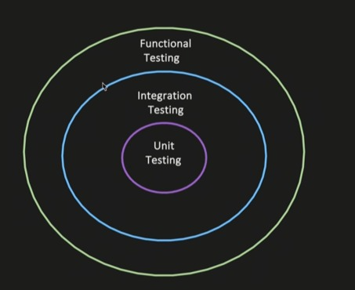

Types of Testing in Java
1. Unit Testing
Unit testing is the testing of an individual unit of code, such as a method or a class, to verify that it works correctly.
Goal: To check whether a small, isolated part of the application behaves as expected.
Example:
- Test whether a calculateTotal() method returns the correct amount.
- Test whether an add() method returns the correct sum.
Unit testing usually uses mocks or stubs to isolate the unit from external dependencies such as databases and APIs.
2. Integration Testing
Integration testing verifies whether multiple modules or components work together correctly.
The goal is not to test the complete end-to-end user journey. Instead, it checks whether different components are properly connected and communicate as expected.
Use Case 1: Service → Repository → Database
Suppose a Java application uses the following architecture:
Service Layer → Repository Layer → Database
The testing process is:
- Invoke a method in the service layer.
- Verify that dependency injection works correctly.
- Verify that the service communicates with the repository.
- Verify that the operation reaches the database.
- Assert that the data is successfully persisted in the database.
Example: When a user registers, the service calls the repository, and the repository saves the user's details in the database.
The integration test verifies that the complete service-to-database flow works correctly.
Use Case 2: Service → Kafka Topic
Suppose a service publishes an event to a Kafka topic.
The testing process is:
- Invoke the service method.
- Verify that the service processes the request correctly.
- Verify that the event is published to the correct Kafka topic.
- Verify that the published message contains the expected data.
The goal is to verify that the service and Kafka messaging system work together correctly.
3. Functional Testing
Functional testing verifies whether an application feature or business function works according to the specified requirements.
The goal is to check whether the system produces the expected results for particular inputs and user actions.
Example: In an online banking application:
- The user enters valid login credentials.
- The system authenticates the user.
- The user requests a balance.
- The system displays the correct account balance.
Functional testing verifies whether the banking functionality behaves as expected.
Functional testing can be performed at different levels. It may test a single feature or an entire business workflow.
4. End-to-End (E2E) Testing
End-to-end testing verifies a complete business workflow across the application's components and external systems, where applicable.
Example: In an online shopping application:
- The user logs in.
- The user searches for a product.
- The user adds the product to the cart.
- The user completes checkout.
- The payment is processed.
- The order is saved and confirmed.
The goal is to verify that the complete workflow works correctly from beginning to end.
Difference Between Testing Types
Testing Type | What It Tests | Example
Unit Testing | An individual method or class in isolation | Test a calculation method
Integration Testing | Interaction between multiple components | Service → Repository → Database
Functional Testing | A feature against business requirements | Verify the login feature
End-to-End Testing | A complete business workflow | Login → Cart → Payment → Order confirmation
Summary
- Unit Testing: Does this individual unit work correctly?
- Integration Testing: Do these components work together correctly?
- Functional Testing: Does this feature satisfy the business requirements?
- End-to-End Testing: Does the complete business workflow work from start to finish?
